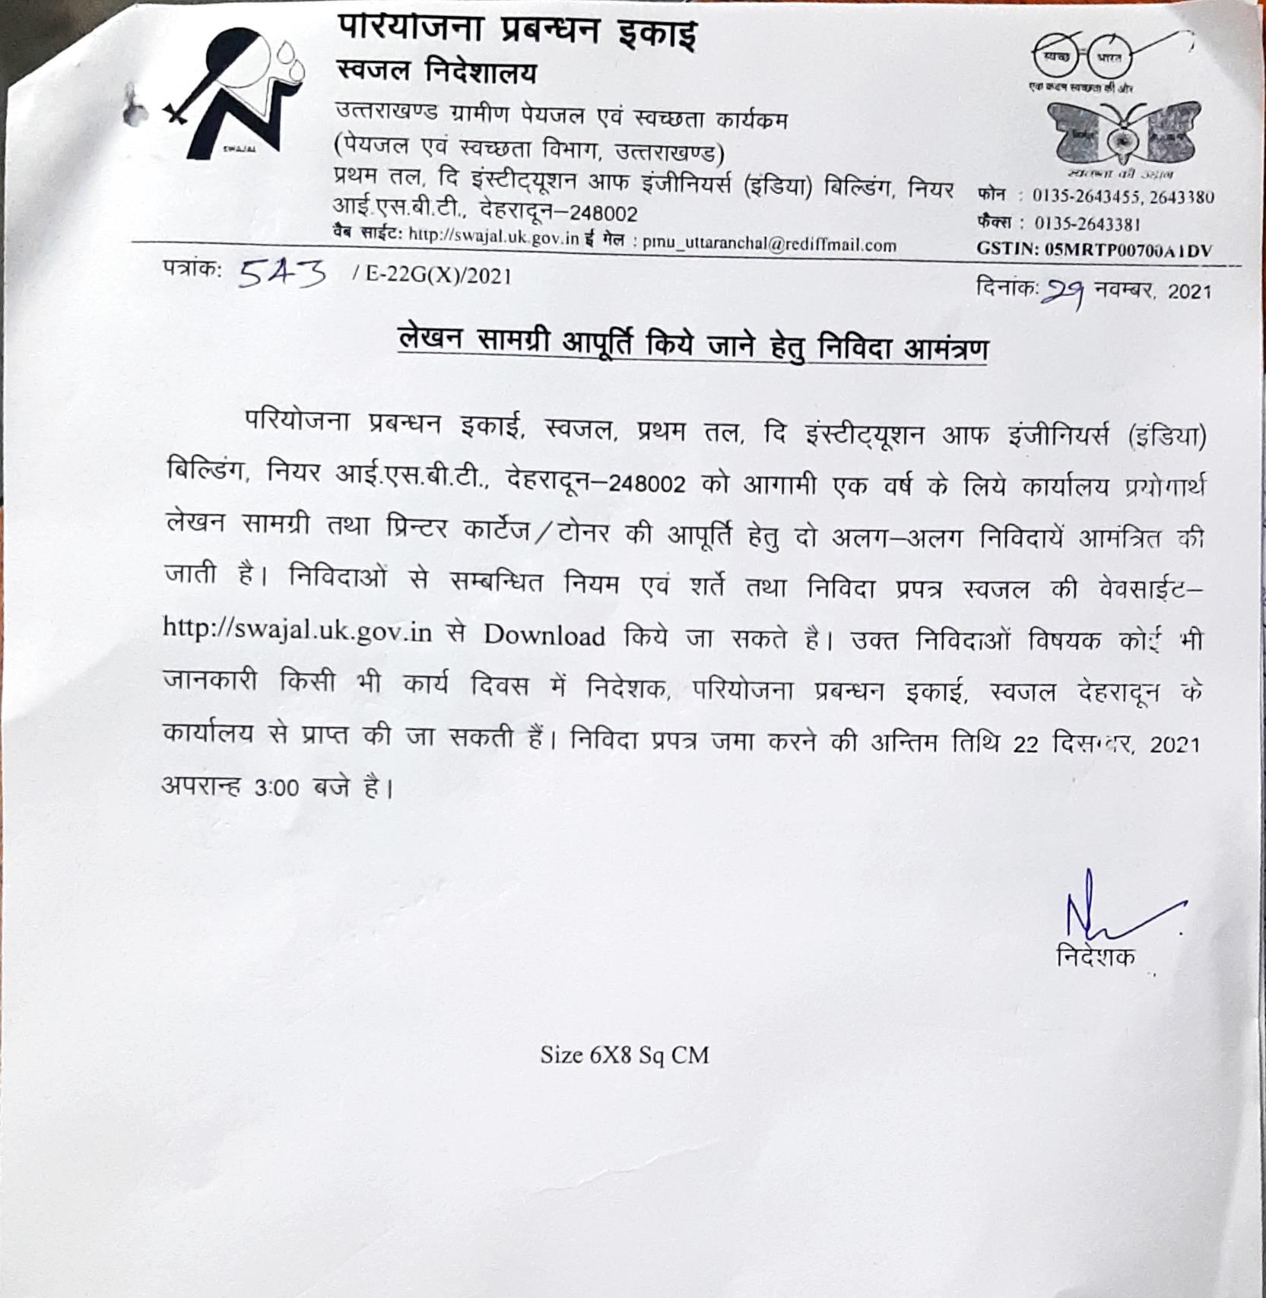

PROJECT MANAGEMENT UNIT-SWAJAL PROJECT
Dehradun- Uttarakhand

Tender No: 01/PMU/2021-22

TENDER DOCUMENT

FOR

Procurement & Supply of Office Stationery

Cost of the Tender Document: Rs. 500/-

 | Project Management Unit  The Swajal Directorate | Phone: 0135-2643455,2643380  Fax: 0135-2643381  Web Site: http://swajal.uk.gov.in  E-mail:pmu_uttaranchal@rediffmail.com
(Department of Drinking Water& Sanitation, Uttarakhand)
First Floor, The Institute of Engineers Building,
Saharanpur Road, Opposite ISBT, Dehradun - 248171

Invitation for Bids
NOTICE INVITING TENDER FOR SUPPLY OF STATIONARY

Tenders as per two bid system i.e. Technical bid and Financial Bid are hereby invited against tender No. 01/PMU/2021-22 for the "Supply of Stationary"
The tender shall be received up to 14:00 Hrs on 22nd December, 2021 at the PMU-Swajal office in Original.

- Completion Time
The completion time for the supply of SUPPLY OF STATIONERY is one week from date of Start.

- Download of Bid Document
The complete bid document can be downloaded from official website i.e. “https://swajal.uk.gov.in”.

- Availability of Bid Document and mode of submission
The bid documents shall be available on the official website i.e. https://swajal.uk.gov.in from 12:00 Hrs dated 23rd September, 2021 and the bids shall have to be submitted in original to this office.

- EMD/Bid Security
Bid Security is exempted as per Government Order no. 121(1)/XXVII(7) / 21-32/2007TC dated 29th April, 2021 . Bid Security Declaration by the Firm on their letter head with duly stamp by authorize signatory shall be uploaded with Technical Proposal.

- Opening of Bid
Bids must be submitted in original to this office. The technical bids (Part-I) will be opened at 15:00 Hrs on 22nd December, 2021by the authorized officers in the office of Director, Project Management Unit-Swajal Project, 1st Floor, The Institution of Engineers (India) Building, Saharanpur Road, Majra, Dehradun, 248002. If the office happens to be closed on the date of opening of the bids as specified, the bids will be opened on the next working day at the same time and venue.
After opening of the Tender Bid part-1, evaluation shall be done and the bidder shall be evaluated for qualification. The list of the technically qualified bidders shall be displayed on the official website i.e. https://swajal.uk.gov.in.
Financial Bid of the eligible bidders shall be opened subsequently for which the details shall be available on “https:// https://swajal.uk.gov.in”.

- Bid Validity Period-Bid shall be valid for a period of 120 days from the date of opening of Technical & Financial Bid.

- Whom to Contact
For any further information on the Bid, the Bidders may contact the office of the Director, Project Management Unit-Swajal Project, 1st Floor, The Institution of Engineers (India) Building, Saharanpur Road, Majra, Dehradun, 248002.
- The Purchaser shall have the right to reject all or any of the Bids and shall not be bound to accept the lowest or any other Bid or to give any reason for such decision.

- Rates quoted in Financial Bid must be including of all taxes.

- Bids for part of work shall not be accepted. The entire work under scope of this tender will be awarded to one party/contractor.

- Submission of Original Documents:
The bidders are required to submit following original documents in the office of Director, Project Management Unit-Swajal Project, 1st Floor, The Institution of Engineers (India) Building, Saharanpur Road, Majra, Dehradun, 248002 in hardcopy.
(a) Bid security Declaration Form.
(b) An affidavit by the bidder regarding correctness of information/documents furnished with bid document and Authorization of Signatory.
Above mentioned original documents must be received to this office before 14:00 Hrs on 22nd December, 2021 either by registered post/courier services or by hand, failing which the bids will be declared non-responsive. If above date happens to be a public holiday, then document may be submitted up to the specified time on the next working day.
To qualify each bidder must fulfill the pre-qualification criteria (clause no.2 of ITB) and submit the above mentioned valid documents. Otherwise bidder’s price bid will not be opened.

Director,
Project Management Unit-Swajal Project

Tender for Supply of "Supply of Stationary" Items

Firms are requested to read the tender document carefully including its terms and conditions, procedures to fill the tender form and tender assessment criteria.
TENDER DOCUMENTS CONSIST THE FOLLOWING:-
- Eligibility criteria
- General Instructions to Tenderers
- General Terms & Conditions of Contract
- Special Terms & Conditions of Contract
- Technical Bid (Annexure "A")
- Financial Bid (Annexure "B")
- Performa of Undertaking (Annexure "C")

ELIGIBILITY CRITERIA
- EXPERIENCE : The bidder must have minimum three years of experience of supplying the Stationery items in bulk to Govt. Departments/PSUs/Nationalized Banks. Copies of two such Purchase Orders (of Rs.1 lac or more) received during each of the last three years should be enclosed.

- ANNUAL TURNOVER: Annual Turnover should be Rs. 02 lacs or more during last 3 financial years i.e. 2018-2019, 2019-2020, 2020-2021. Complete audited annual turnover report with profit & Loss, balance sheet, income and expenditure reports for last 3 financial years i.e. 2018-2019, 2019-2020, 2020-2021 to be submitted along with the technical bid.

- STATUTORY REGISTRATIONS : The firm must have valid PAN No. and G.S.T. No.

INSTRUCTIONS FOR THE TENDERERS
- TENDERS are invited from reputed suppliers fulfilling the eligibility criteria mentioned in these tender documents for the supply of stationery items as per the list enclosed.
1.1 Signing of Tender: Individuals signing tender or other documents connected with the contract specify:
(1.i) Whether signing as a “Sole Proprietor" of the firm or his attorney.
(1.ii) Whether signing as a “Registered Active Partner" of the firm or his attorney.
(1.iii) In the case of companies and firms registered under the Indian Partnership Act/the Companies Act, the capacity in which signing, e.g. Secretary, Manager, Partner etc. or their attorney and produce copy of a document, empowering him to do so, it called upon to do so. In case of unregistered firms all the members of the firm should sign the tender and relevant documents. Each page of the Tender document and papers uploaded on e procurement portal along with, should be numbered, signed and stamped by the authorized signatory as a token of acceptance of the terms and conditions laid down by the PMU- Swajal Office.
- VALIDITY OF TENDERS: The validity of rates quoted will be for a period of one year from the date of award of contract. However, the Director (Incharge) may extend the validity for further period of one year on same terms, conditions and rates.
- DOCUMENTS TO BE ATTACHED WITH TECHNICAL BID:
- Original Tender Document duly signed with seal of the firm on each page in token of acceptance of the terms and conditions of tender.
- EMD Declaration Form.
- Complete audited annual turnover report with profit & Loss, balance sheet, income and expenditure reports for last 3 financial years i.e. 2018-19, 2019-20, 2020-21.
- Photocopy of PAN No. and GST No. of the Firm/Company/Proprietor.
- Trade Tax return in for last 3 years i.e. 2018-2019, 2019-2020, 2020-2021 in support of the annual turn over .
- Copies of two Purchase Orders (of Rs.1 lac or more) received from Govt. Departments/ PSUs/Nationalized Banks during each of the last three financial years i.e. 2018-2019, 2019-2020, 2020-2021 in support of the experience.
- The undertaking (Annexure-“C") duly signed by the tenderer.
All the aforesaid documents must be enclosed with the Technical Bid, failing which, the tender shall not be considered. The documents should be signed with seal by the tenderer/bidder.

PRICES:
- Price should be quoted for all the items listed in Annexure "B" without any overwriting/erasing/cutting. Use of white fluid/ correction fluid/ correction tape is strictly prohibited.
- GST should be inclusive for each item. Price Bids showing rates like "Tax excluded /Excluding of tax " etc. are not acceptable and such offer shall not be considered.
- The rates should be inclusive of freight charges, packing charges etc.
Conditional bids shall be rejected.
- The rates for the quoted items should not be higher than those quoted in any other organization/institution or the M.R.P.
- Successful tenderer shall not be entitled to any hike in prices for any reason other than statutory levies during the period of contract.
- The tenderers are advised to quote their rates on the basis of costing/profitability of individual items because the Director PMU- Swajal, Dehradun reserves the right to exclude any item(s) from purchase at the time of placing purchase order. Further, the quantities mentioned in the price bid are only tentative in nature and actual procurement quantities of items may differ as per requirement.
- RIGHT OF REJECTION OF TENDER: The Director PMU- Swajal, Dehradun reserves the right to accept or reject any or all the tenders without assigning any reason.
- EVALUATION OF BIDS: On the basis of assessment of general conditions and receipt of EMD and cost of Tender, Technical Bids of only qualified bidders shall be considered for evaluation by the Technical Evaluation Committee constituted by the Competent Authority. Thereafter, on the basis of the evaluation of Technical Bid/Bids, the financial bid/bids of only those technically accepted offers shall be opened online for evaluation. The final award of tender shall be made to the lowest rates qualified bidder on the basis of total cost of procurement (inclusive of GST) worked out in the price bid. The tenderers may note that quantities mentioned in the price bid are only tentative in nature and are meant only for the purpose of evaluation of tender. Actual procurement quantities of items may differ as per requirement.

GENERAL TERMS & CONDITIONS OF CONTRACT
- DELIVERY OF STATIONERY: The time and the date of delivery of stores stipulated in the purchase order shall be deemed to be the essence of the contract. The delivery should be made to the office of Director PMU- Swajal, First Floor, The Institute of Engineers Building, Saharanpur Road, Opposite ISBT, Dehradun – 248171 within 07 days from the date of dispatch of purchase order.
- The supply shall have to be made in full.
- If the contractor fails to execute the supply order, in full or in part, within stipulated time, the items will be procured from elsewhere and the extra expenditure incurred on the risk purchase will be recovered from the contractor.
- PACKING OF STORES: Tenderer/Bidder/Dealer should supply the stores with proper packing and making for transit so as to be received at the destination without any loss or damage of the item/items.
- PAYMENT: Payment shall be made after receipt of complete items mentioned in the purchase orders and due inspection by the nominated official of PMU- Swajal. No advance payment shall be made.
- SUBLETTING OF CONTRACT: The Tenderer shall not sublet, transfer or assign the tender. In the event of the contractor contravening this condition, the Director PMU- Swajal has right to terminate the contract.
- PENALTY CLAUSE & RISK PURCHASE- The contractor will be bound to supply the items within stipulated period, failing which liquidated damages will be recovered for default on the part of the supplier in delivery of goods beyond scheduled delivery dates.
- For Delay in Supply- Penalty of 0.5% for each week of the value of the order calculated at the contract rate will be levied. The maximum penalty for late supply shall not exceed 10 % of total value of order/orders.
- For Non Supply- If the order is still not supplied, the supply order will be canceled and the item will be procured from elsewhere and the difference will be recovered from subsequent bills/security money deposit of the contractor. The cut-off date of delivery period shall be counted from the date of actual dispatch of supply orders to date of receipt of supplies at destination. Failure to supply the items 3 times during the validity of the contract may result in blacklisting of firm for a period of not less than 3 years.
- DISPUTES AND ARBITRATION : In case of any dispute the decision of the Director PMU- Swajal will be final. The venue of any arbitration shall be Dehradun. The Director PMU- Swajal also reserves the right to terminate the contract at any time without assigning any reason(s) therefore.

SPECIAL TERMS & CONDITIONS OF CONTRACT
- Technical Specifications: The Specifications of Stationery items offered by the tenderer must tally with the specifications mentioned in the tender document (Annexure "B")
- Inspection of supplies: Supplies shall be accepted subject to the complete satisfaction of Director or his representative. Any defect found in the materials / stores supplied will render the supplies open to rejection and decision of the Director, shall be final and legally binding. The rejected stationery shall have to take the same back at their own cost and risk, and the contractor shall replace such rejections with the items of standard specifications / quality as acceptable to the Director, PMU- Swajal office. Alternatively, the stationery may, at the discretion of the authority, be purchased from others at the risks and costs of the tenderer.

Annexure –“A”

TECHNICAL BID

- Name of Firm :

- Address for Correspondence:
- TeleNo./FaxNo. and E-mail address:
- Person responsible for conduct of business:
- PAN No.:
- G.S.T. No.:
- Annual Turnover: 2018-2019
2019-2020
2020-2021

Details of Purchase Orders received from Govt. Departments/PSUs/Nationalized Banks

2018-2019 | (1) | Value Rs.
 | (2) | Value Rs.
2019-2020 | (1) | Value Rs.
 | (2) | Value Rs.
2020-2021 | (1) | Value Rs.
 | (2) | Value Rs.

I , proprietor/partner/director of
(name of the company/firm) hereby declare that the information given in this form is true and correct to the best of my knowledge and belief.

Dated: Signature with Stamp Place :

List of Goods Annexure -B
Following items are required in different section of PMU for F.Y. 2021-22
S.N. | Description | Total Demand | Rate per unit | GST | Total
1 | 2 | 3 | 4 | 5 | 6(4+5)
1 | Photo State Paper A-4 size | 237
2 | File Cover | 170
3 | Gaurd File | 48
4 | Reynolds Pen Blue | 24
5 | Reynolds Pen Blue | 12
6 | Pilot Pen | 20
7 | Add Zel Pen | 13
8 | Pencil | 39
9 | Stappler Pin Big | 49
10 | Stappler Pin Small | 64
11 | Stappler Small | 5
12 | Duster Small Khandi | 27
13 | Note Pad 40 Page | 16
14 | Gum Bottle | 8
15 | Cello Tape | 32
16 | Correction Fluide | 35
17 | Binding Tape | 16
18 | Paper Flage | 49
19 | Refill Cello Griper | 11
20 | Ball Pen Blue | 22
21 | Note Sheet Pad | 92
22 | Pencil Cutter | 114
23 | Correction Flude Pen | 26
24 | Register 2 Quire 144 Page | 20
25 | U Clip Largel | 23
26 | U Clip Small | 23
27 | Allpin | 7
28 | Rubber | 20
29 | Permanent Marker | 22
30 | Highlighter | 25
31 | Tag Small | 14
32 | Tag Big | 14
33 | Glue Stick | 37
34 | Gum Tube | 15
35 | Dak Pad | 7
36 | Steel Scal Large | 5
37 | Envelop A4 Size | 1300
38 | Envelop Medium Size | 1300
39 | Envelop Small Size | 1300
40 | Receipt Register | 3
41 | Despatch Register | 3

Annexure- “C”
To,
The Director,
PMU- Swajal, 1st Floor,
Institution of Engineers India Building,
Saharanpur road, Majra
Dehradun

Sir,

I/We do hereby solemnly declare and undertake that:
- The terms & conditions of the tender is acceptable in complete. If any information in the tender submitted by me is found incorrect/false, at any time, the tender/ contract is liable to be rejected.
- The firm is in this business since last three years.
- The items quoted by me/us have not been and are not being supplied to any other Govt organization /institution in Dehradun region at rates lower than those quoted here and the rates quoted in this tender are not more than M.R.P. of the items.
- The items quoted are of standard quality and workmanship.
- The firm is not black listed in any Govt. organization/institution.

For and on behalf of the firm (Firms Name & Address)
(Signature of Authorised Signatory) Name :
Designation:
Seal:

